E. SAKTHI PRIYA
192520041
1.USE CASE DIAGRAM
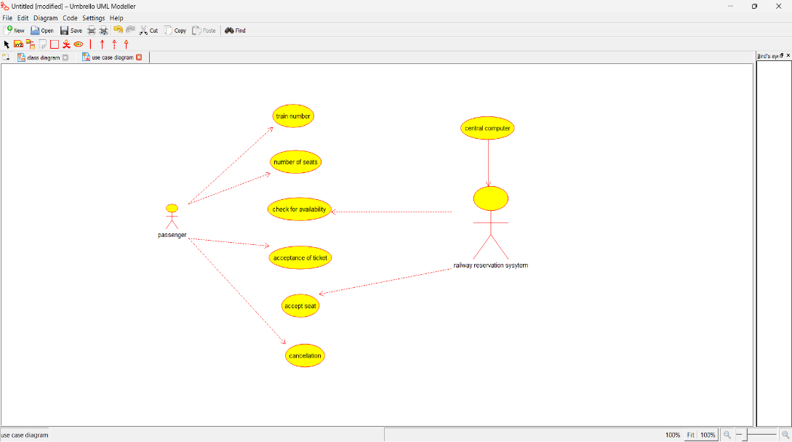

2. CLASS DIAGRAM
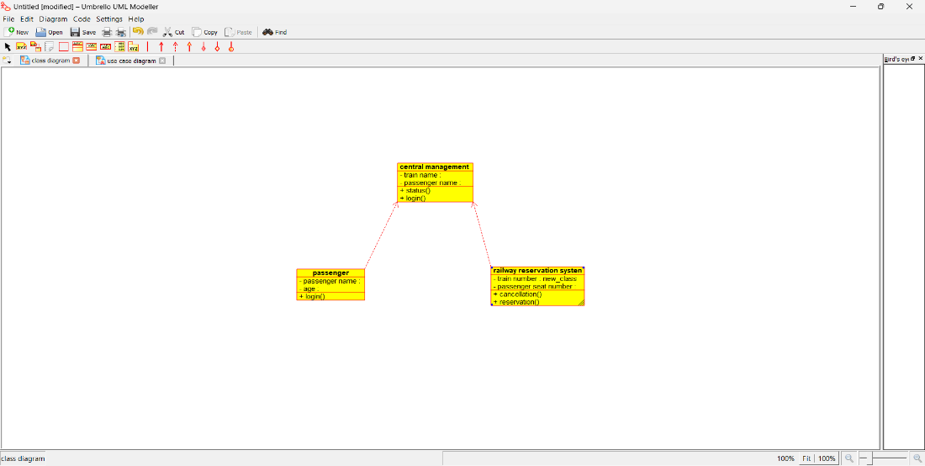

3. ACTIVITY DIAGRAM

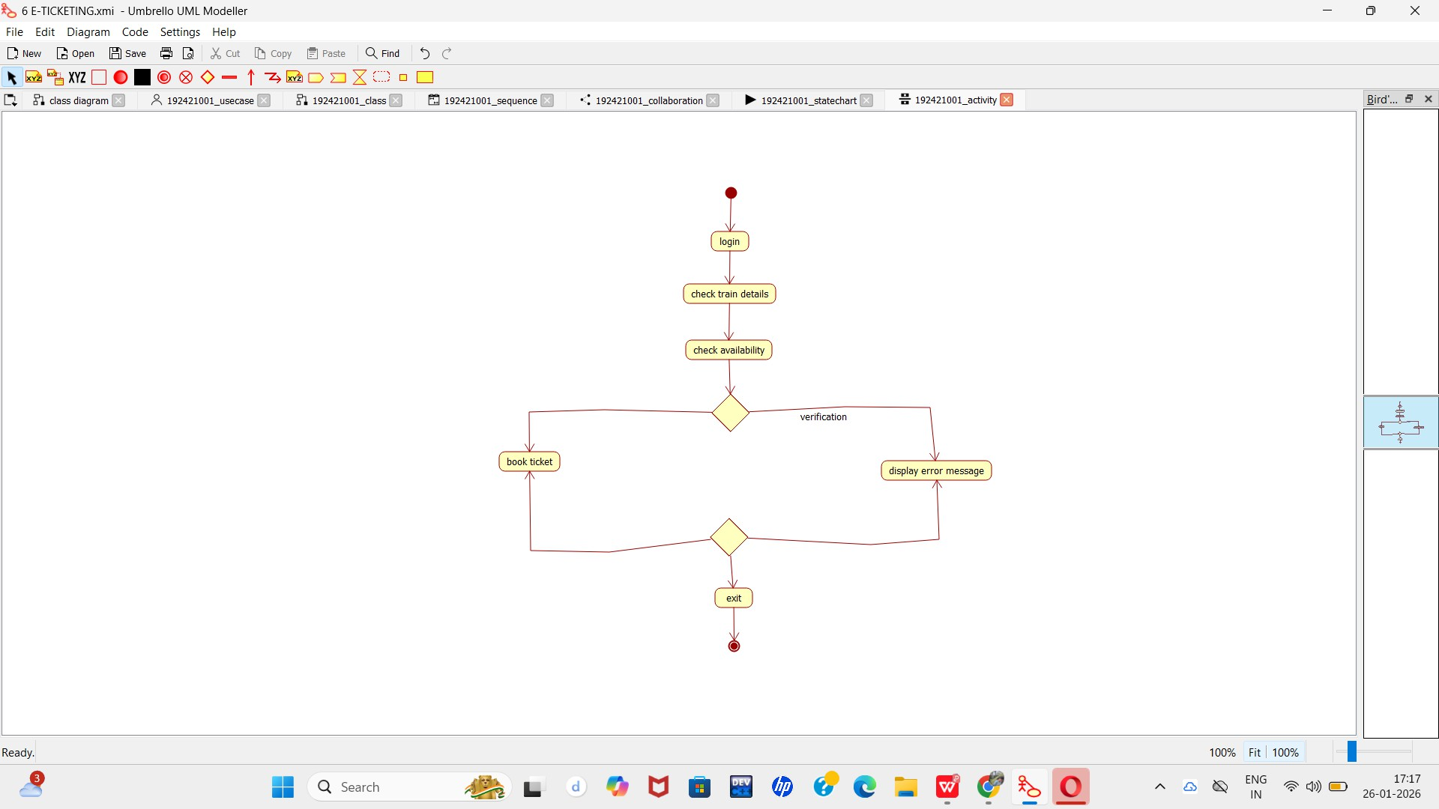

4. SEQUENCE DIAGRAM
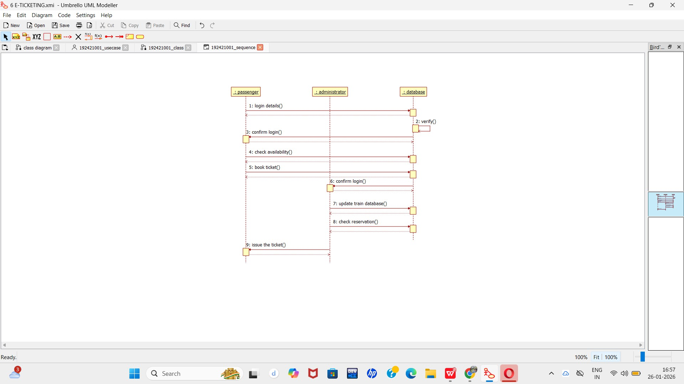

5. COLLABORATION DIAGRAM
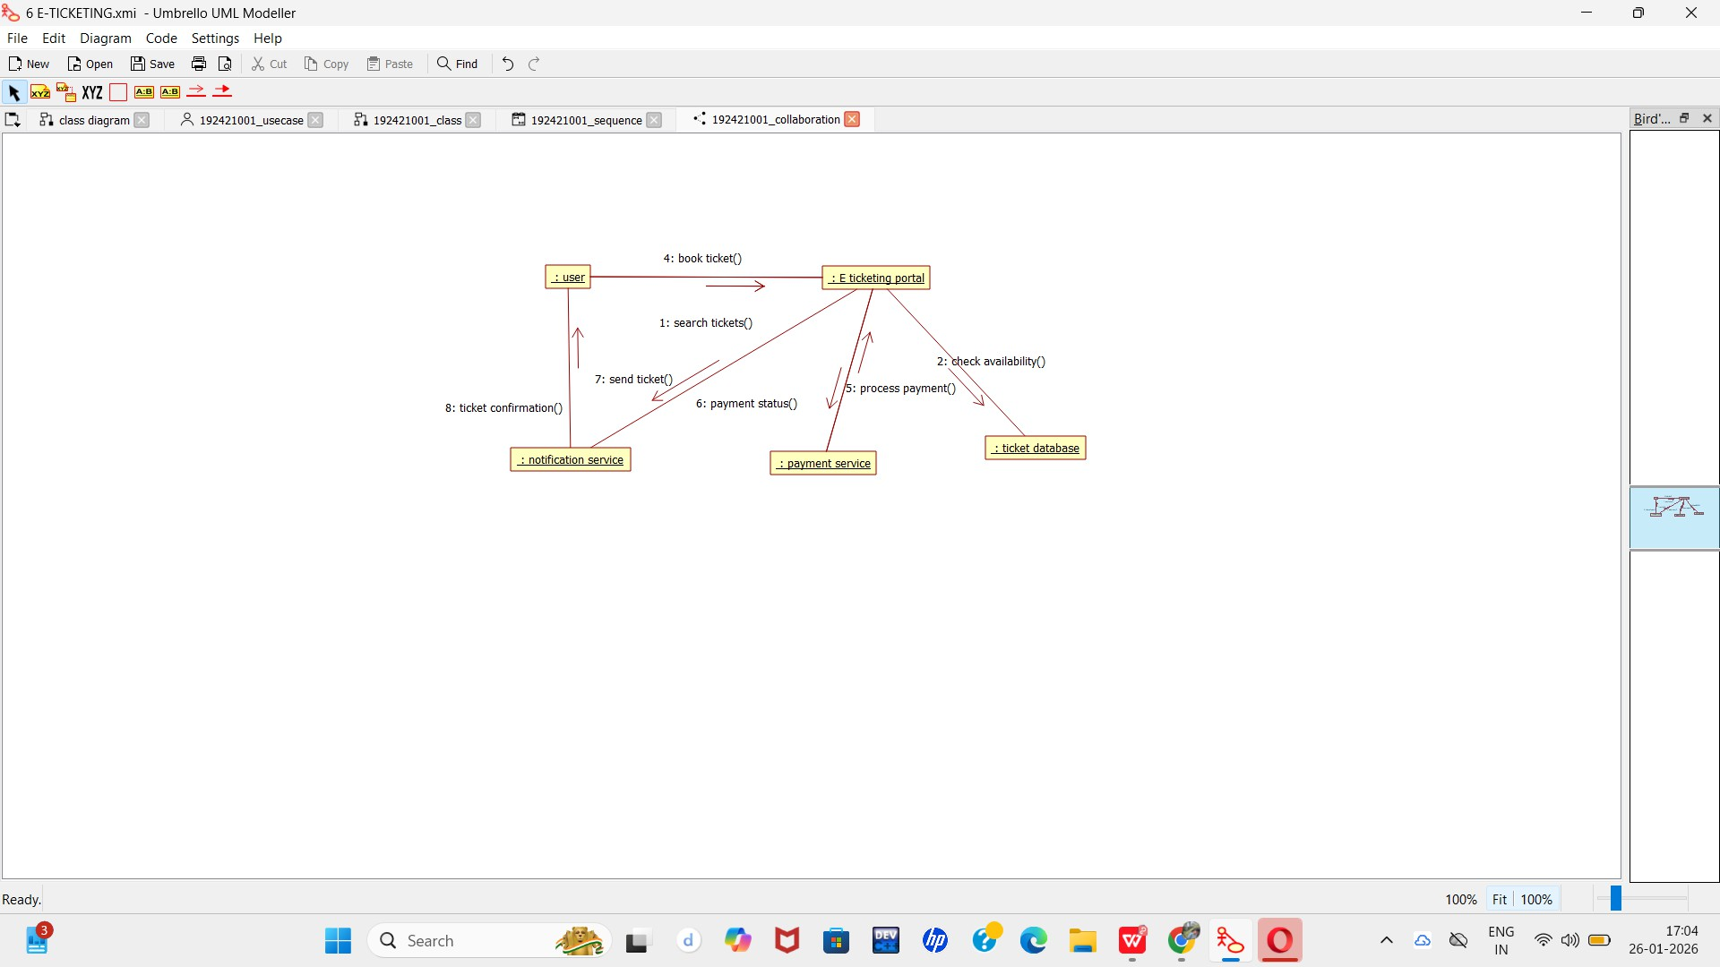

6. STATECHART DIAGRAM
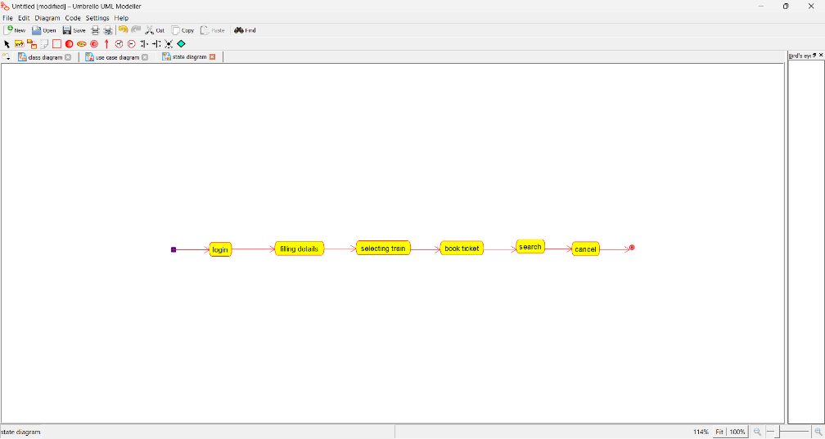

7. COMPONENT DIAGRAM
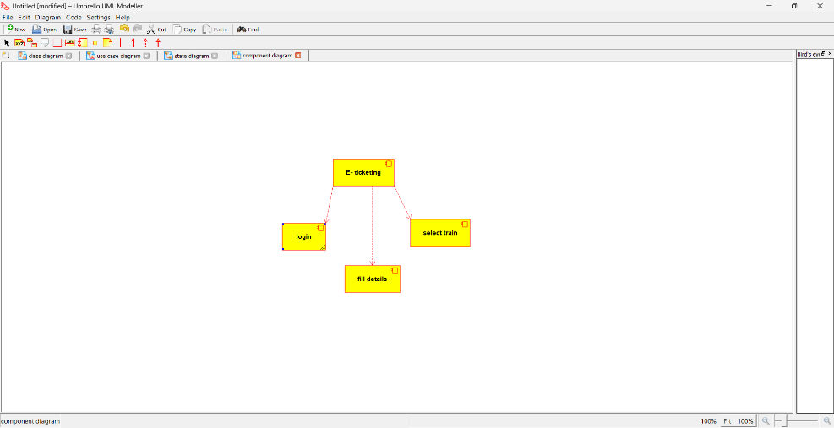

8. DEPLOYMENT DIAGRAM
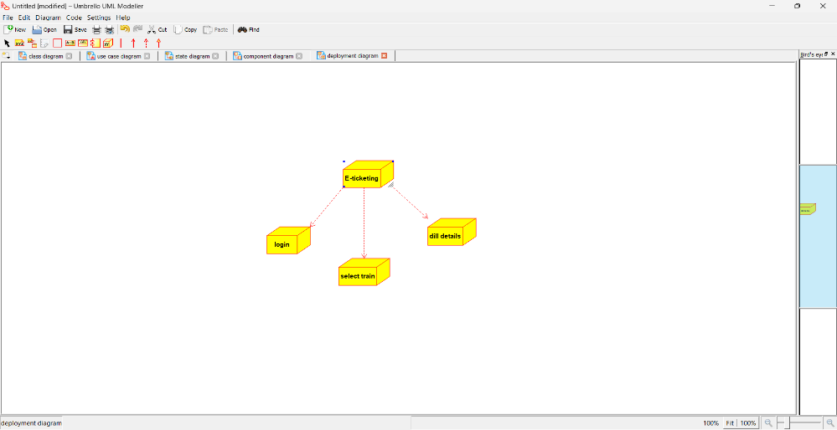

9. PACKAGE DIAGRAM
